The Craigievar Express

The Museum is the proud owner of Postie Lawson’s most famous invention, ‘The Craigievar Express’. It’s getting a bit frail now but it is still an extraordinary example of what one person can do when he/she sets their mind to it. Make sure you have a good look at it.

The Express is a steam driven, coal powered, three wheeled vehicle. Postie built it in 1895 as his own ‘horseless carriage’, a type of vehicle that was just coming in. He could not afford or make a vehicle powered by the latest invention, the internal combustion engine, but he was very interested in steam power especially in railway engines and wanted to experiment with steam power in a smaller vehicle he could build from scratch fairly cheaply.

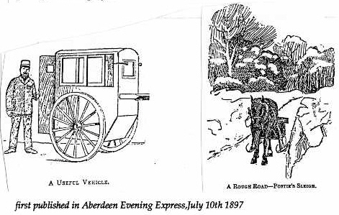 | Postie’s normal method of mail delivery was to use a pony, the faithful ‘Kate’, and a cart. Sometimes a sleigh came in handy.
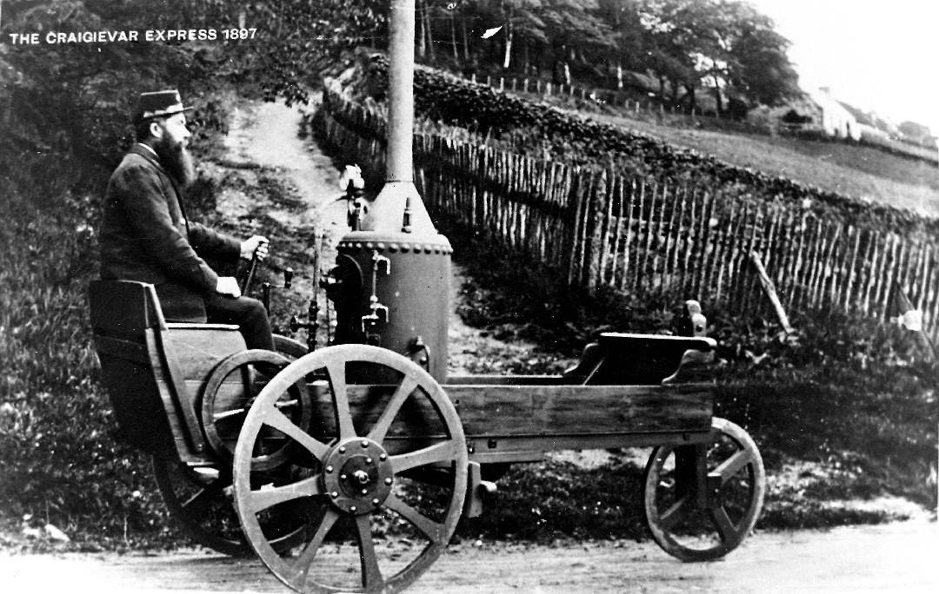 | This is what he was interested in using instead, so the story goes.  Do you notice the little caption? This is a postcard picture and shows that Postie and the Craigievar Express were quite famous.

The Construction of the Craigievar Express

Postie was not a rich man so he built the Express as cheaply as he could, using mostly recycled parts.
The main frame and wheels are made of wood. It was cheap and plentiful and Postie was a very skilled carpenter. He used local pine for the frame, floorboards, sides and seat. The boiler and engine are carried on a strong oak sub- frame.
The boiler and the engine are both second hand. The small bore boiler came from England via an advert in a very famous magazine called ‘The Exchange and Mart’ which Postie read every week. The little single cylinder steam engine came from an Aberdeen sawmill. The engine had been used to power a saw for making up bundles of firewood, so it was probably older than the ‘Express’ itself. The gauge glass, pressure gauge, safety valve and other fittings for the boiler were supplied and fitted by an Aberdeen firm.
The gears appear to be re-used from a machine tool drive. Postie included a differential in his design that allowed the rear wheels to turn at different rates when cornering. Most engineers of Postie’s time would have considered a differential unnecessary for a vehicle with such a narrow track or width.
The ‘Express’ has two braking systems that were both standard practice in 1895. When the Express is moving, a simple flywheel brake slows down the engine and hence the vehicle. When the Express is still, a horse carriage brake acts on the rims of the rear wheels to stop them moving.
The steering is operated by a vertical lever held in the driver’s left hand - a bit like the tiller of a boat. If the driver were to let go, the front wheel would turn to full lock in either direction which means that the Express would stop very suddenly and turn over. (The only recorded accident to the ‘Express’ was caused by steering failure. Fortunately nobody was hurt.)
The iron tyres to the wheels were fitted by the blacksmith at nearby Lumphanan and it is thought that he also produced the chimney with its attached conical smoke-box and the ash-pan arrangement.
The suspension was designed by Postie himself and acts on the rear wheels only.
Postie later wrote to the magazine ‘English Mechanic and World of Science’, commenting that his ‘steam motor car’ was a good hill climber but it was difficult to keep steam up at all times. He also wrote that ‘If coals were cheaper, I should have had it going a good deal’.

Postie planned to finish the Express in time to complete his postal journey on Queen Victoria’s Diamond Jubilee Day. (June 22nd 1897.) However he could not manage it. On the following Saturday morning of 26th June, Postie successfully steamed up the Express and did his postal run from the Old Schoolhouse Croft to Whitehouse, showing just what could be done with ingenuity, determination and invention.

