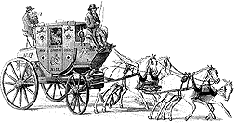

OUR ROADS
EXHIBITION

- Find the milestone in the room.
What number is painted on it?

- How many tools can you spot in
the 1920’s roadman’s wheelbarrow?

- What is the 1760 measuring wheel made from? ………………………………

LOOK AT THE GOOD YEAR ROAD SIGNS CHART

- How many people can you count in the road signs

and how many vehicles

- Find the black and white road sign that
warned vehicles that a corner was ahead.
Draw it in the box.

- How many animals can you count in the Roads Exhibition?

- When is a watering can NOT
a watering can? ………………………………………………………………….

- Measure yourselves on the ruler by the Roads Surveys case. Who is/are the tallest in your group?

………………………………………………………………………………………

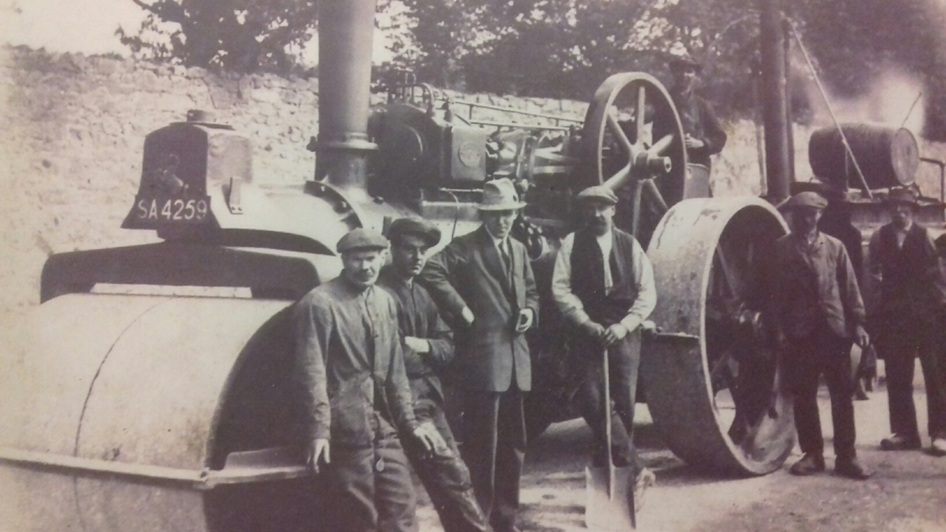LOOK CAREFULLY AT THE BIG AVELING & PORTER ROAD ROLLER

(the photo on your left shows it at work)

- Does its engine use electricity, steam or petrol?

- How many wheels can you find on it?

- What does the steering wheel use to
steer the big roller? ……...…………………………………………………………

- What animal does the roller have as its emblem? ..……………………………

FIND THE MACHINE THAT HAS THE REGISTRATION NUMBER AV9614?

- What was this used for? .………………………………………………………….

- In what year was the Bedford Dormobile made?

- Does its engine use electricity, steam or petrol?

FIND THE BOWTOP CARAVAN IN WHICH A TRAVELLING FAMILY WOULD HAVE LIVED NEARLY 100 YEARS AGO. CAREFULLY TAKE A LOOK INSIDE.

- Where do you think the children would have slept?

…………………………………………………………………………………………

- How do you think it moved about? ……………………………………………...

- In what year was the Nissan Leaf made?

- Does its engine use electricity, steam or petrol?
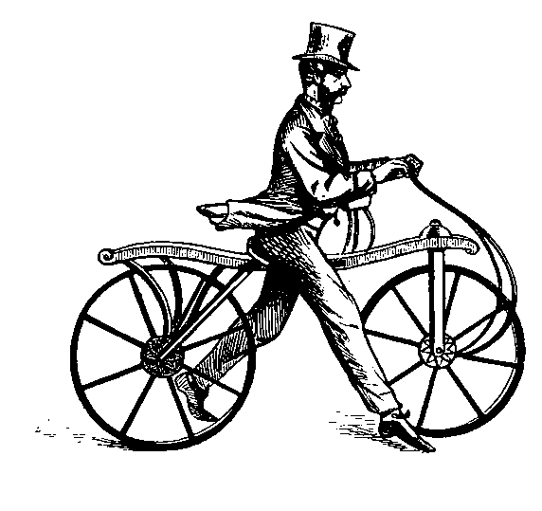CYCLING EXHIBITION (upstairs)

In 1817, a German civil servant put two wheels in line with a steering handle. The machine had no pedals and the rider propelled the device forwards with his legs.

1. | The inventor was |  | and his  invention
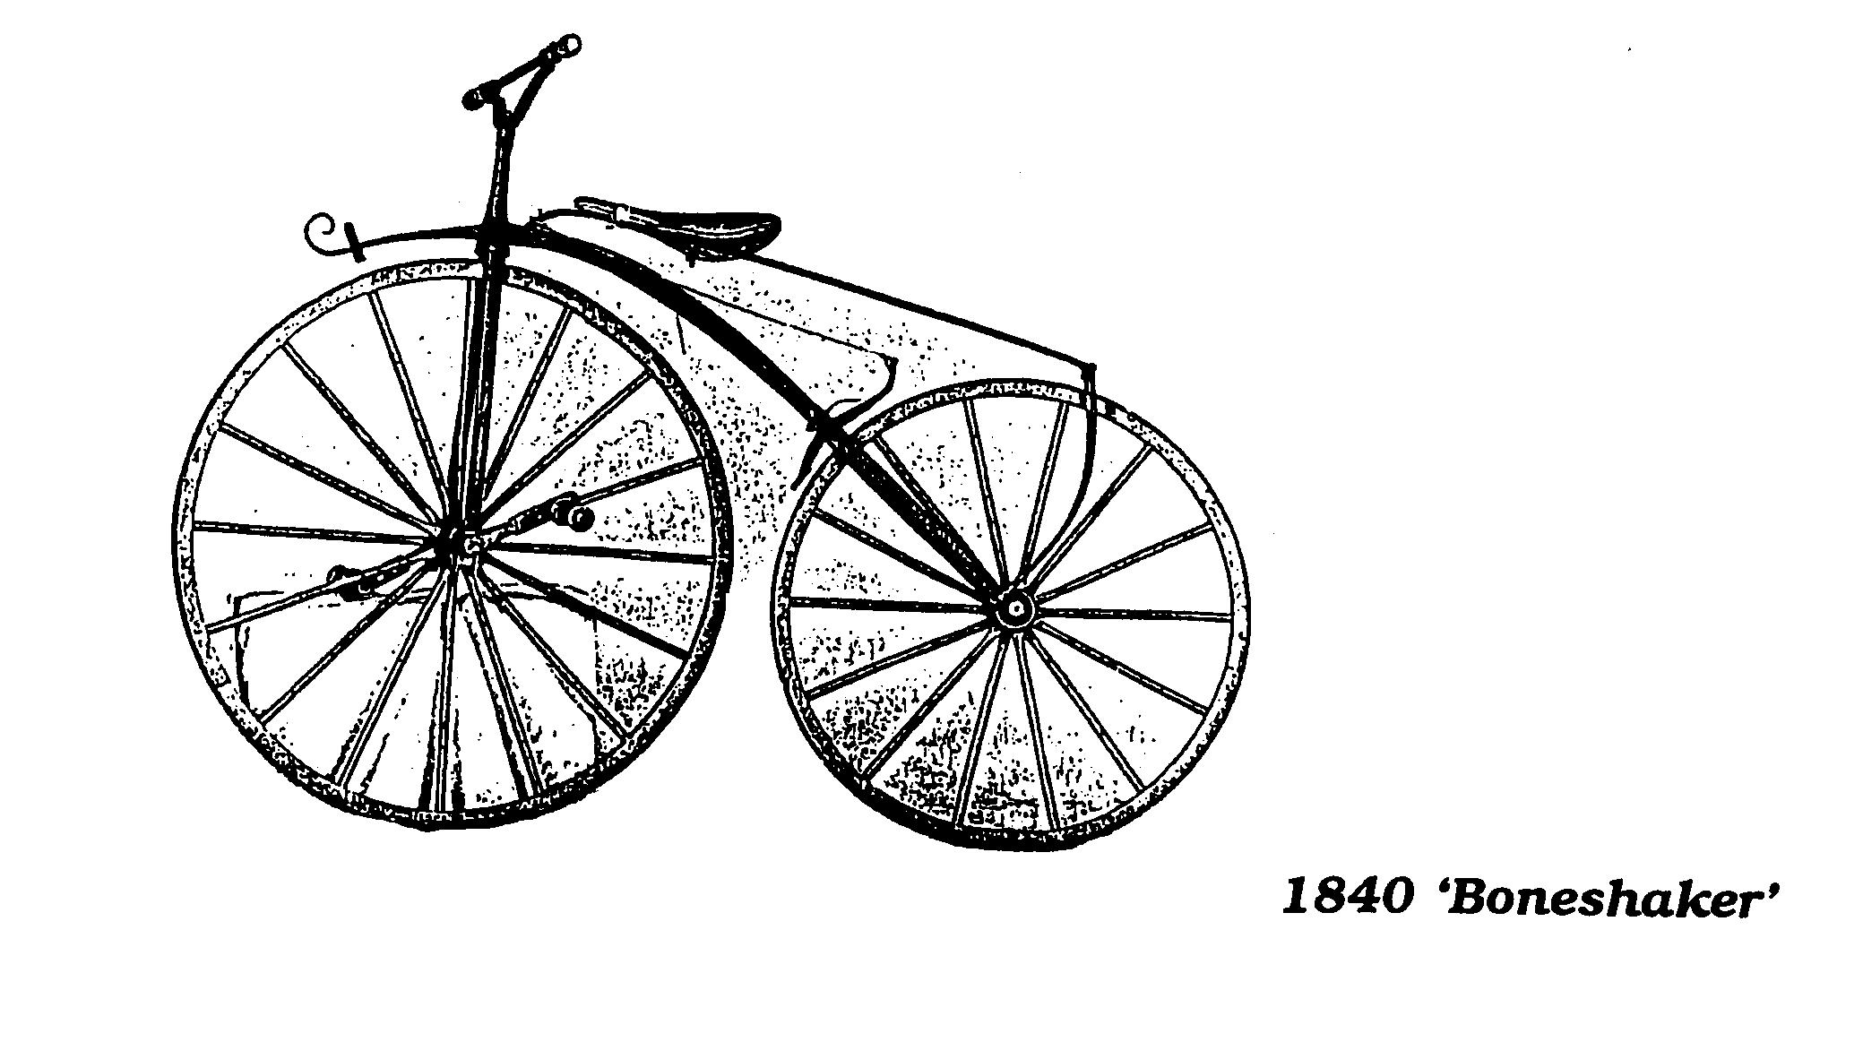
The next bicycle to become popular was ‘The Velocipede’.

2. | What was its common name?

Penny Farthings or ‘Ordinaries’ were made between 1873 and 1885. They had a very much larger front wheel to raise gearing and go very fast. However they were extremely dangerous.

3. | Can you give 3 reasons why they were not safe? | 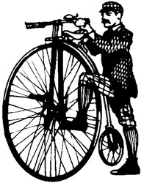
a)

b)

c)

The ‘Safety’ cycle was introduced in the 1880s and its design has basically been the same ever since.

4. | Can you give 3 reasons why they were called safety cycles?
a)

b)

c)

CLIMB ABOARD VEHICLES

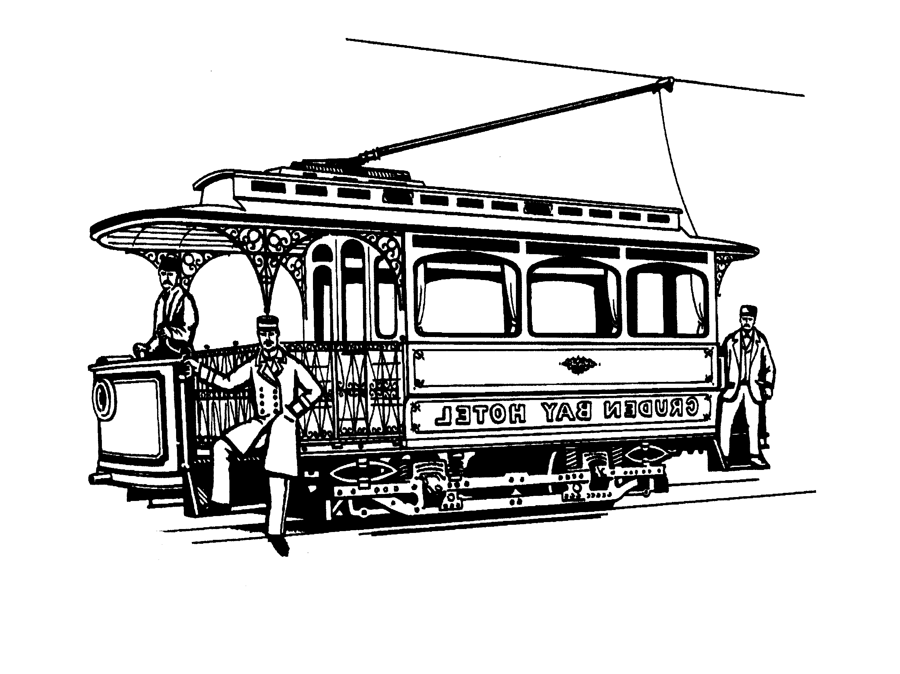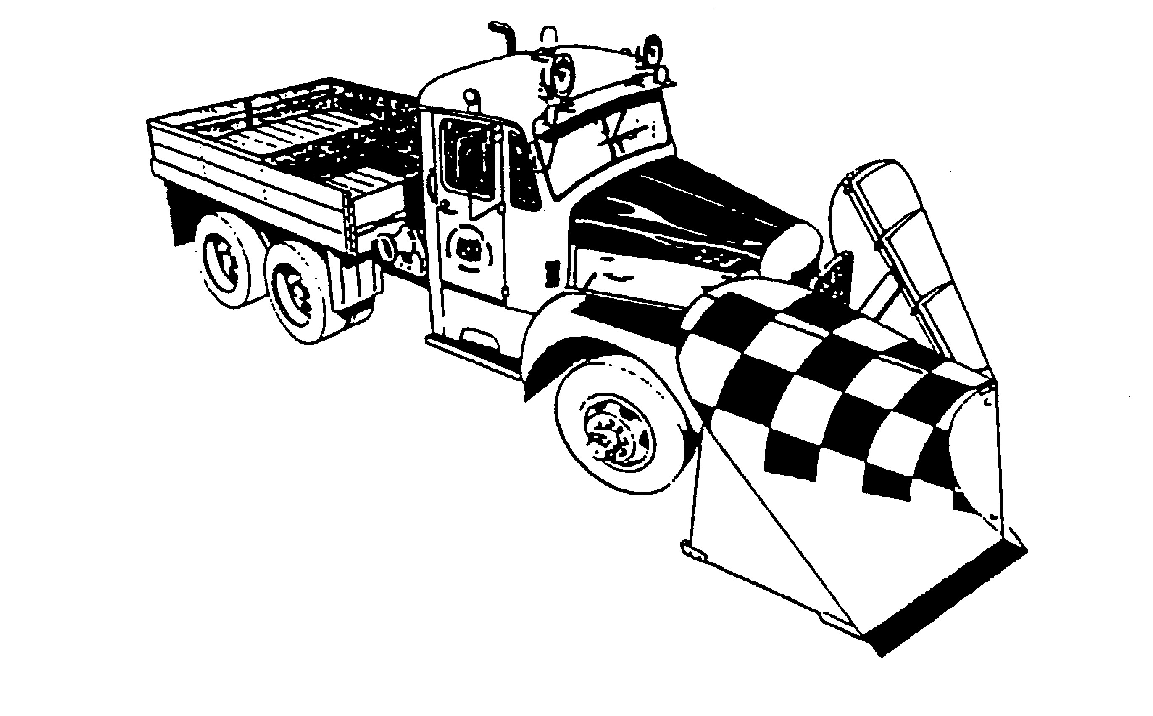Now find the exhibits below and carefully climb aboard them. Write down underneath each drawing the name of the vehicle.
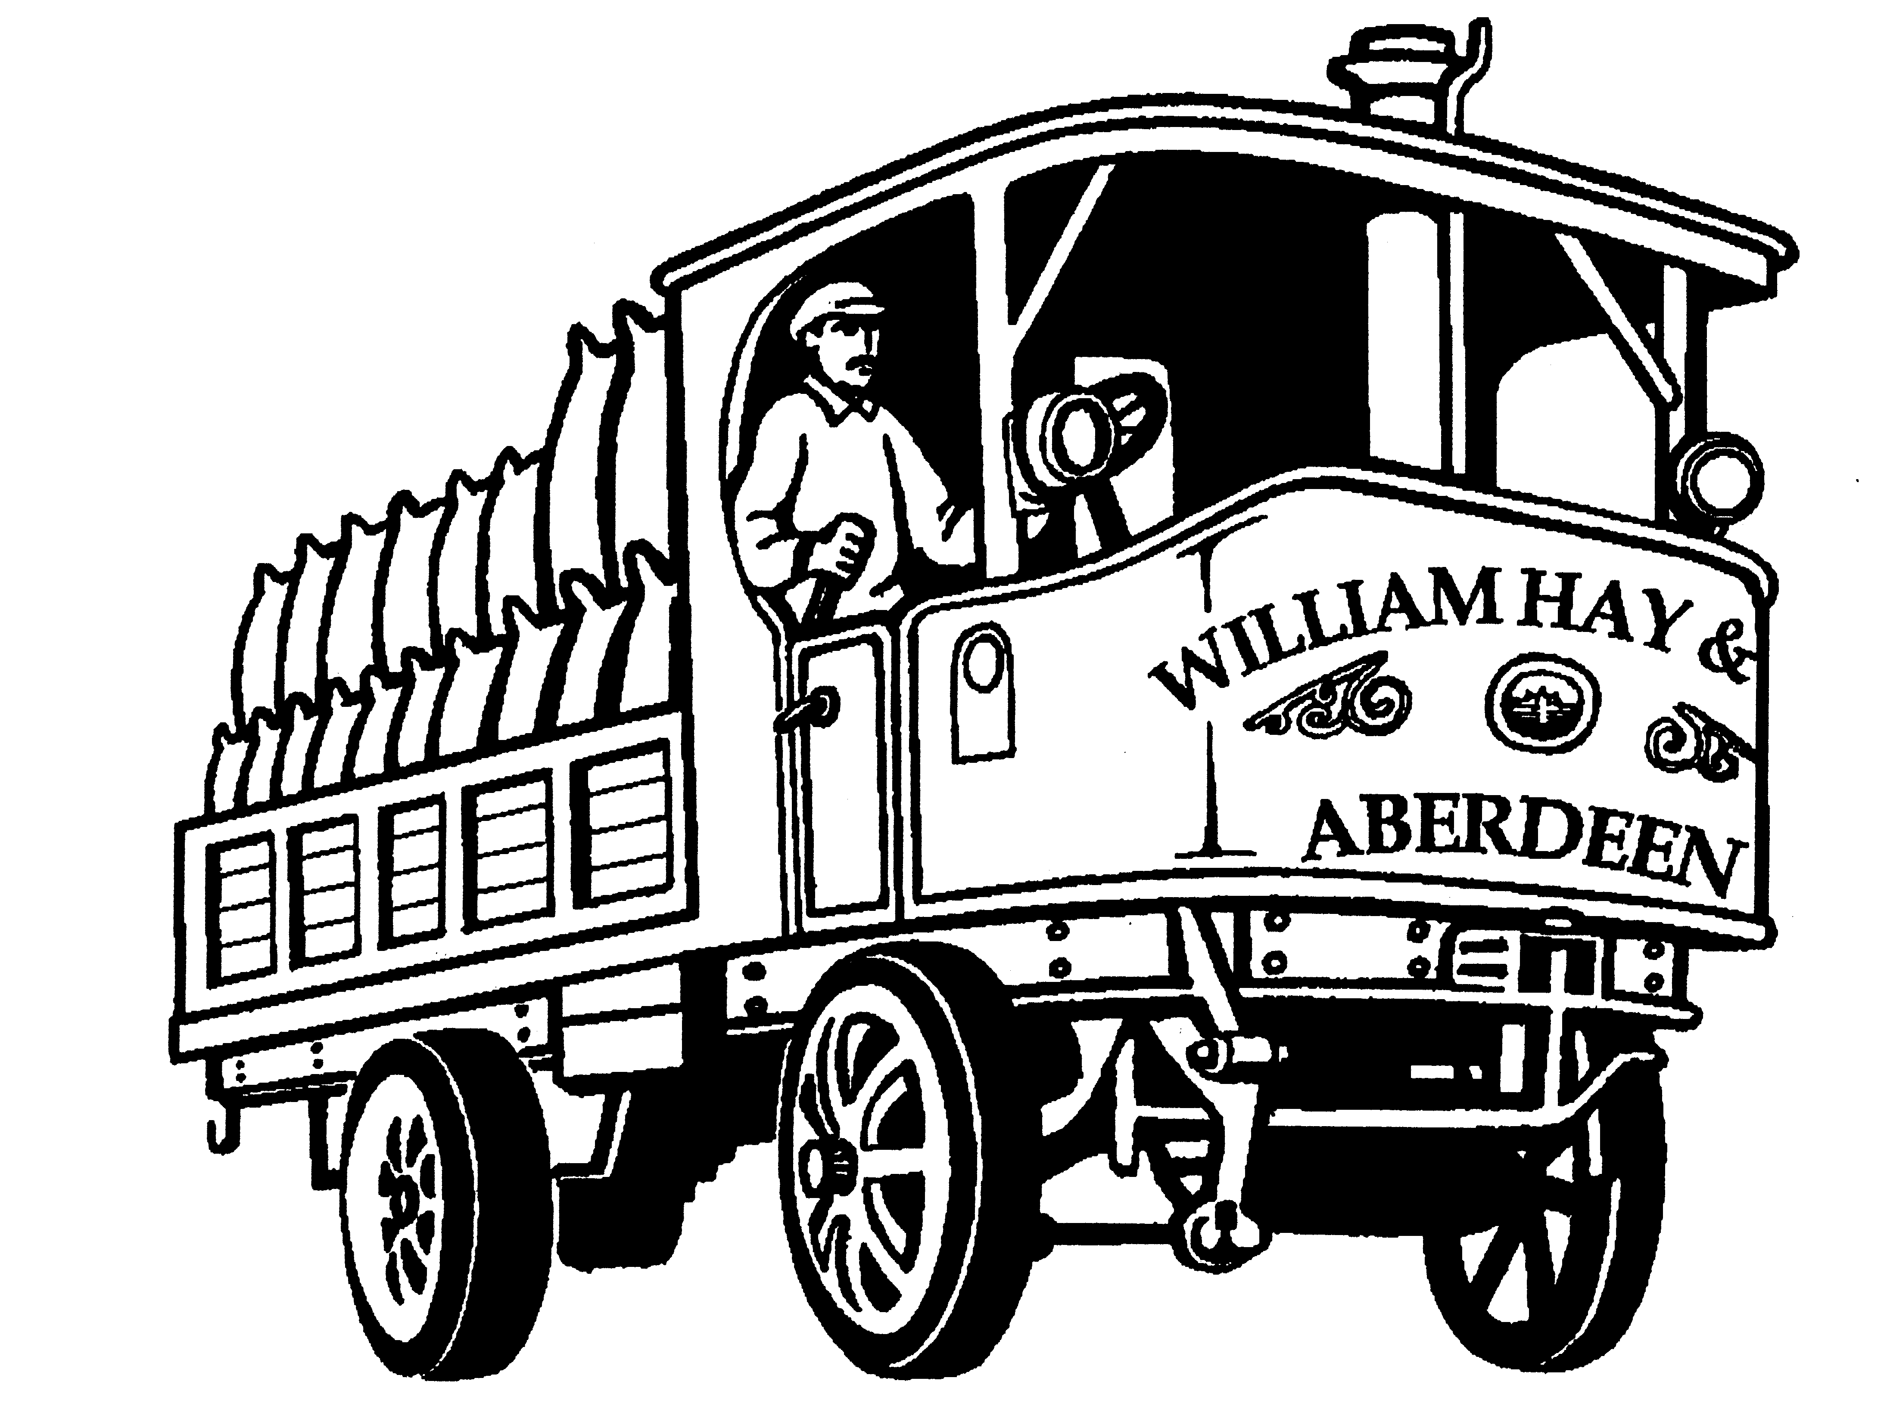

________________________ ________________________ _____________________

How did you travel to school this morning? Put a circle round one or more of the following:

bus scooter car bicycle train motorbike

on foot tram lorry horse carriage van

If you could travel to school tomorrow in one of the museum’s vehicles, which one would you choose?

________________________________________________________________________

