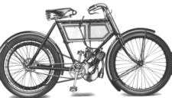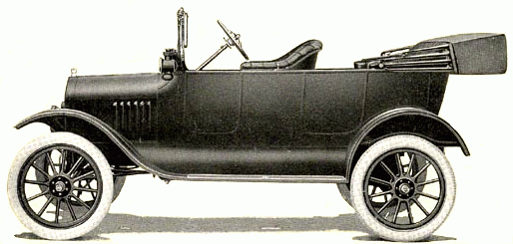A Visit to the
Grampian Transport Museum

1. There are lots of different types of transport. As you go round the museum, point out different vehicles to your teacher or partner. Put a circle round the vehicles listed below as you spot them.

Sedan chair Electric Rally car Police car

Travelling Chariot Penny farthing Steam lorry

Tram Milk Float Hobby horse

2. Have you noticed that vehicles have different kinds of wheels and some have more wheels than others? In the boxes put the number of wheels that the following vehicles have:

Craigievar Express Boneshaker
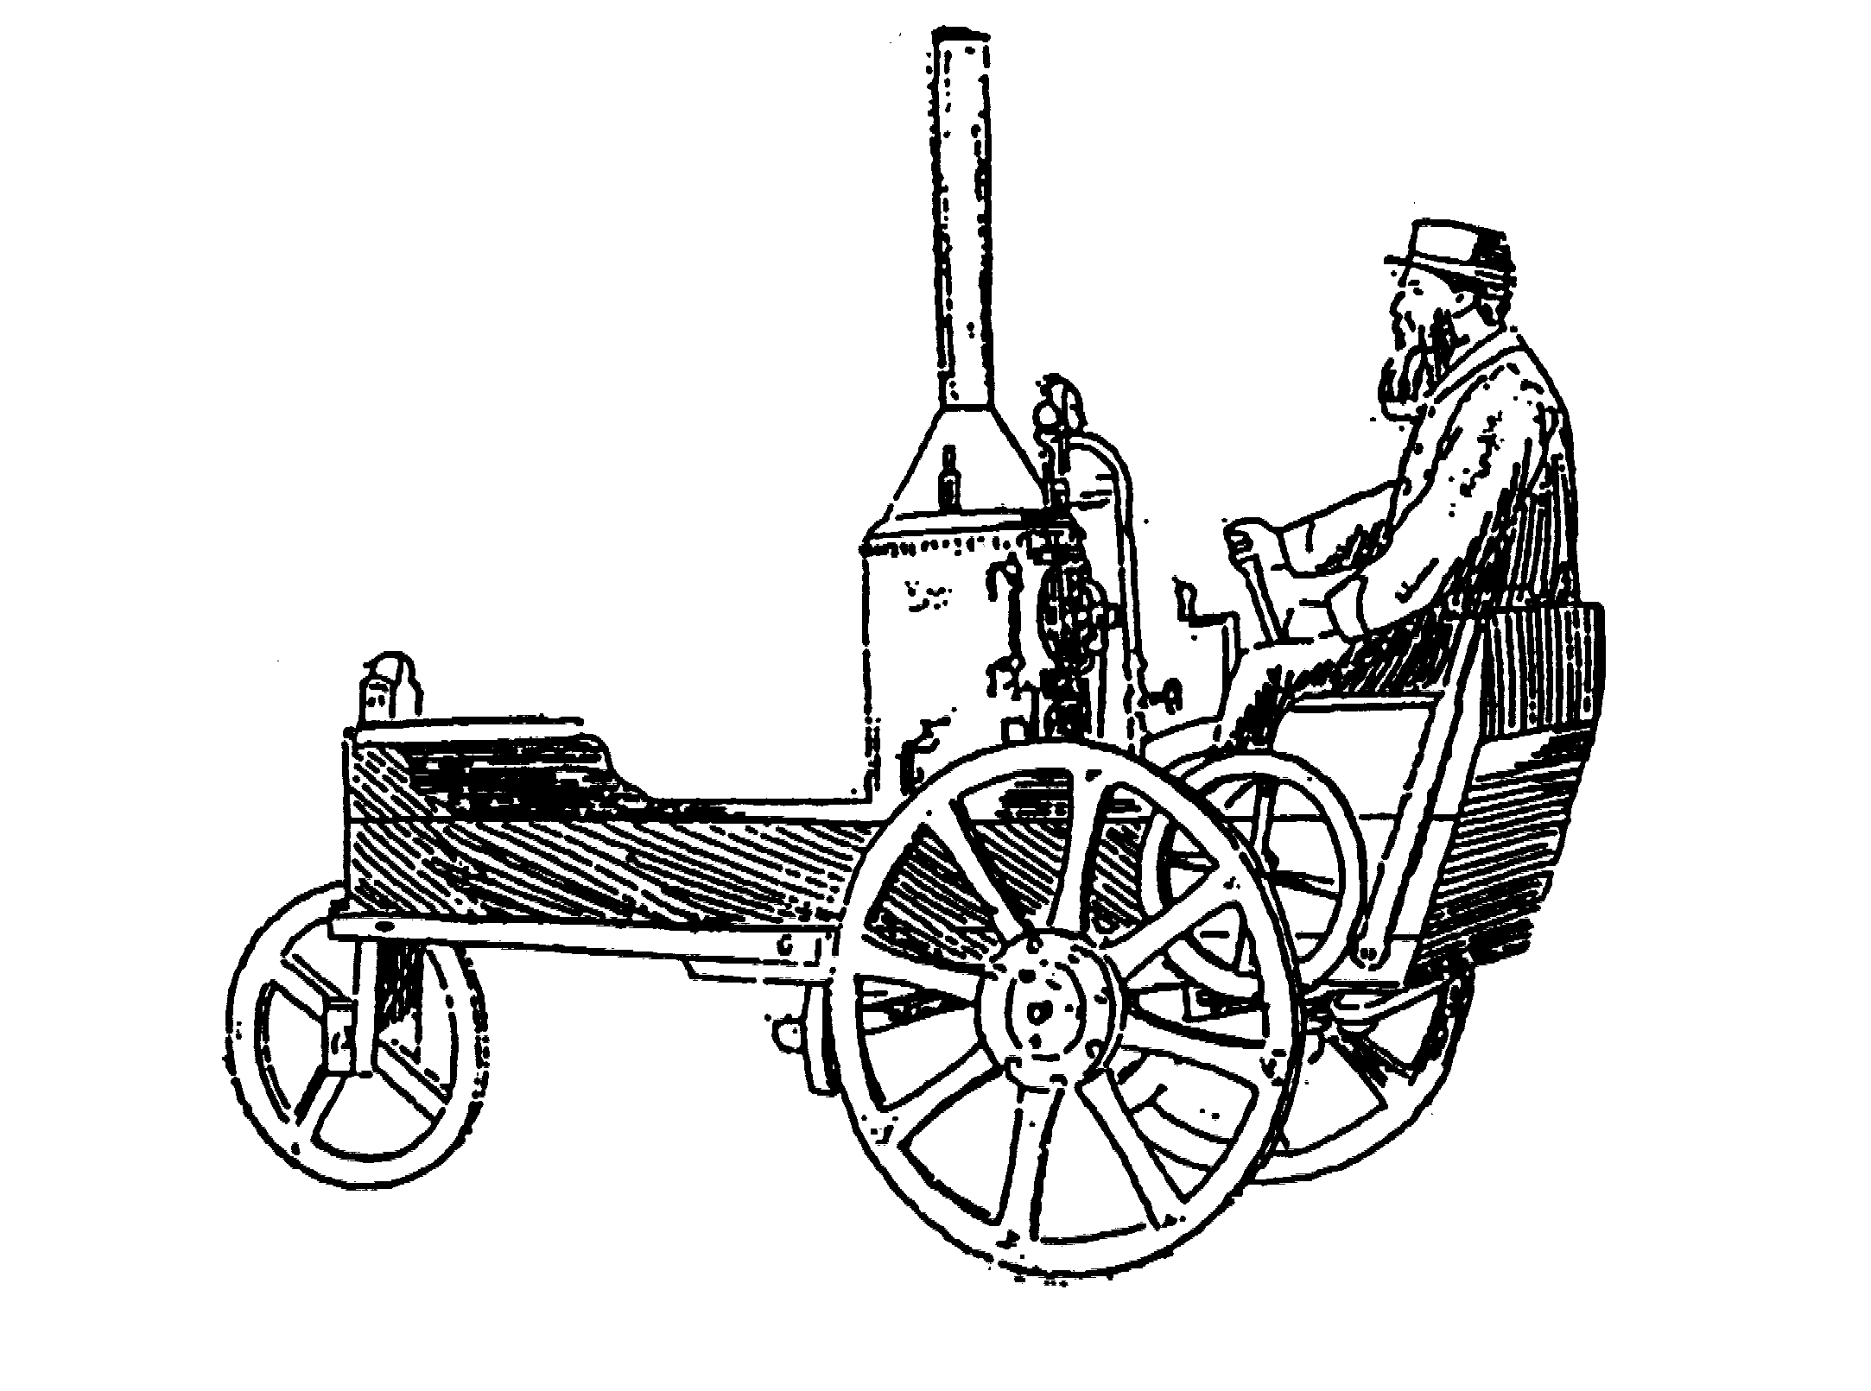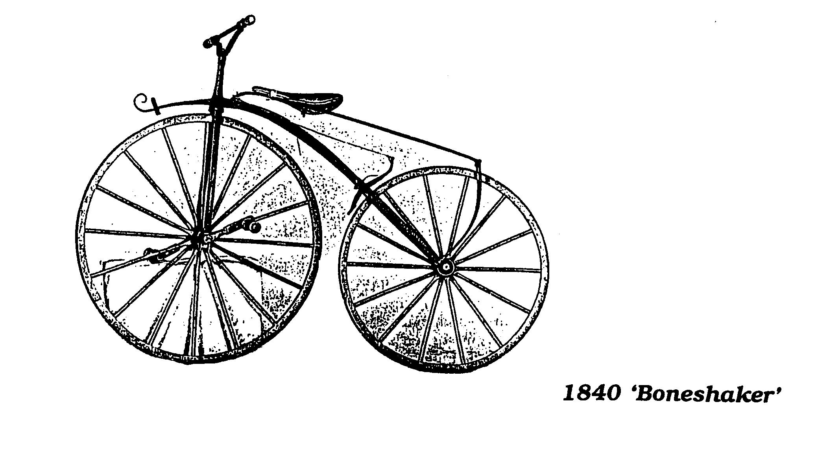

Mack snowplough
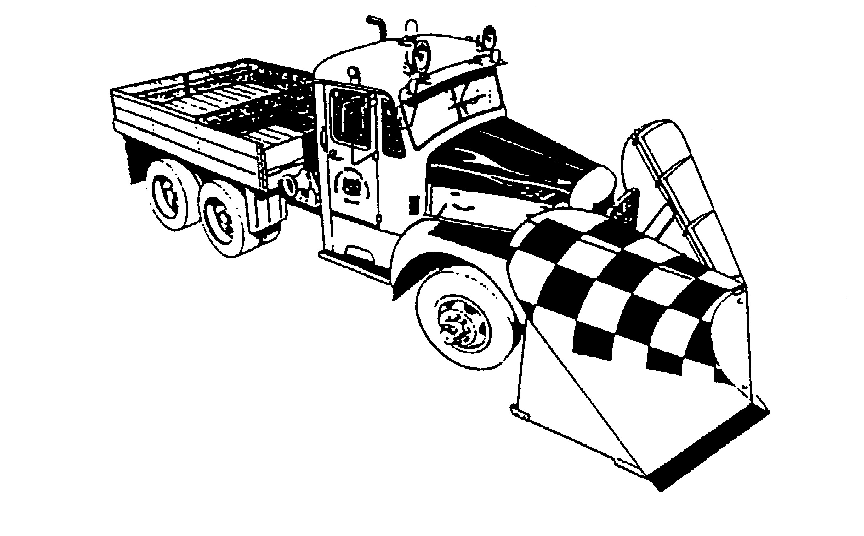
Ner-A-Car

3. Some vehicles have engines to make them go, others don’t. Find the exhibits below. Put a circle round those that don’t have engines.

‘Hero’ stage coach Ford Model T Penny farthing

Cruden Bay tramcar Horse drawn tram Sedan chair

Halley motor lorry Sentinel steam wagon Ferrari F40
4. Think about the different jobs some vehicles have to do. Can you find vehicles in the museum that would have had a special job to do? Tick the boxes as you find the ones below.

Albion fire engine Ice cream tricycle

Brougham carriage Ford Ecostar

5. Find the caravan in which a travelling family would have lived a long time ago. Take a look inside. Where do you think the children would have slept?

______________________________________________________

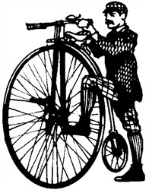6. Now find the exhibits below and carefully climb aboard them. Write down underneath each drawing the name of the vehicle.
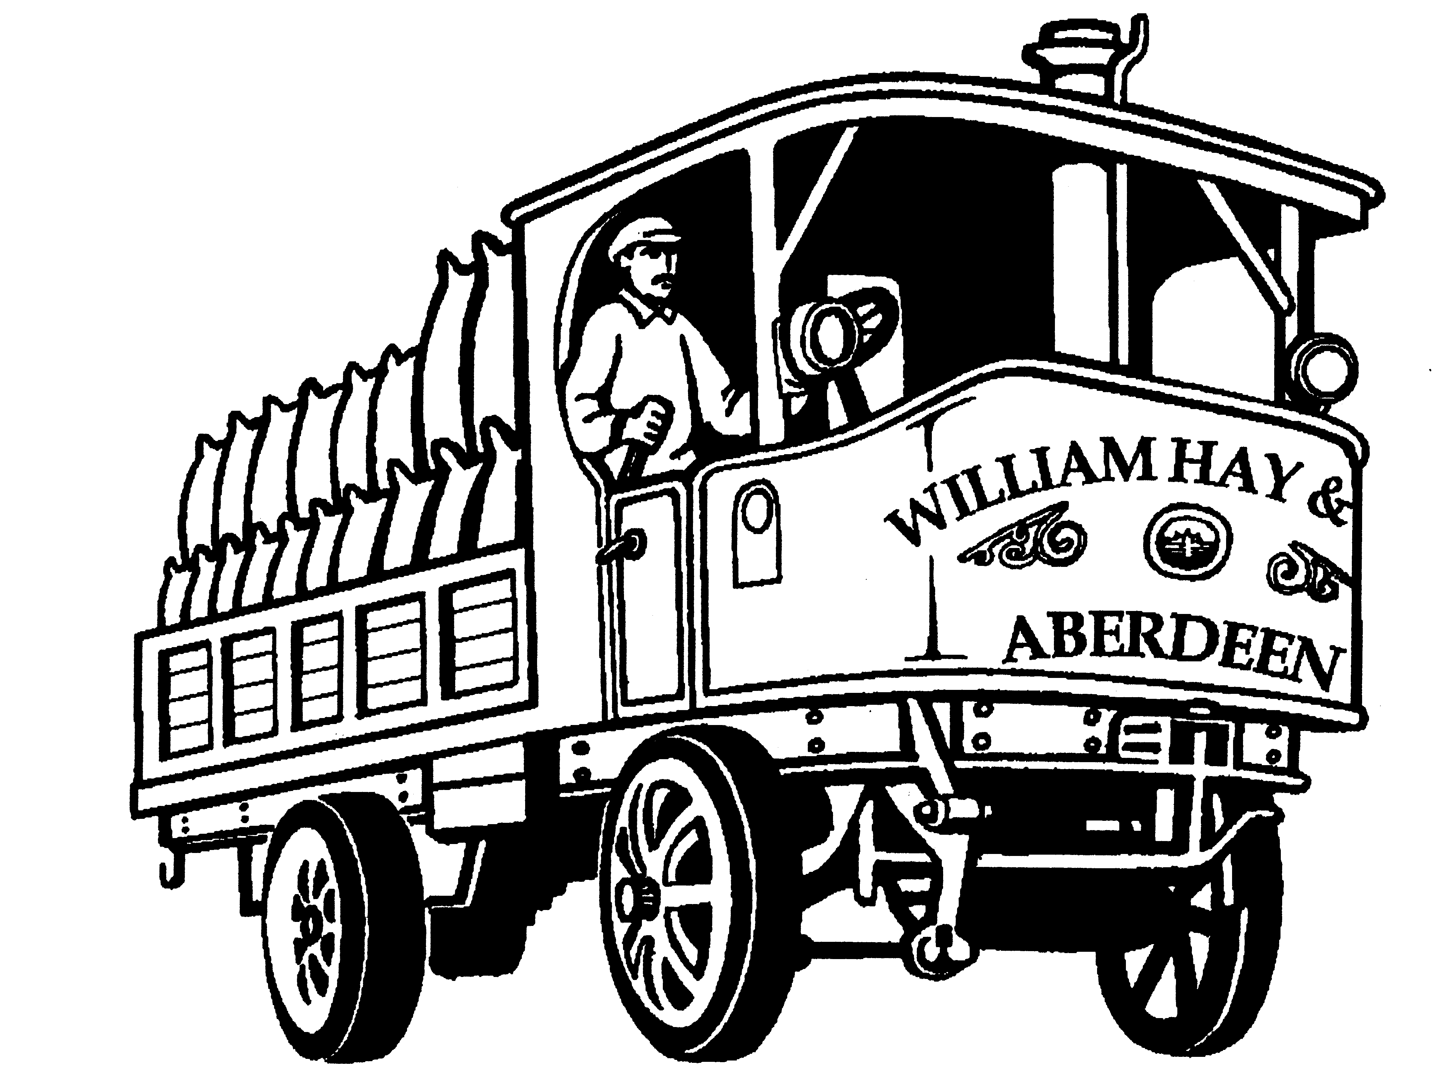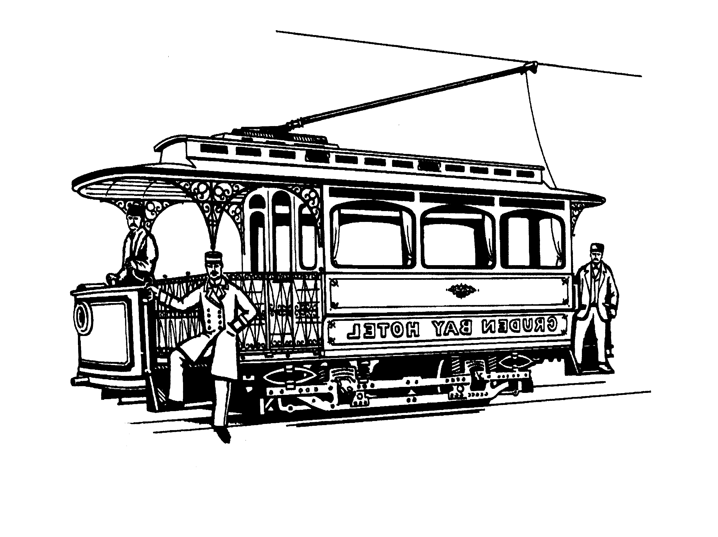
_____________ __________________ ________________

7. How did you travel to school this morning? Put a circle round one or more of the following:

bus scooter bicycle train van motorbike

on foot car tram lorry horse carriage

8. If you could travel to school tomorrow in one of the museum’s vehicles, which one would you choose?

______________________________________________________

